1. open settings.py

from pathlib import Path

import os

1. DEBUG

^ = os.environ.get('DJANGO_DEBUG','') != 'False'

1. SECRET KEY

^ = os.environ.get('DJANGO_SECRET_KEY','amik secret key dari website')

1. create Procfile file outside the two folders

^ web: gunicorn KPMB.wsgi --log-file –

1. bukak new terminal
2. Text

   Description automatically generated
3. ^ pip3 install gunicorn
4. pip3 install dj-database-url
5. bukak settings.py
6. import dj_database_url
7. gi bawah sekali kat settings.py then letak

^ #configure database

db_from_env = dj_database_url.config(conn_max_age=500)

DATABASES['default'].update(db_from_env)

1. open terminal
2. ^ pip3 install psycop2-binary
3. tutup terminal, gi kat settings.py balik
4. cari bahagian static

STATIC_ROOT = BASE_DIR / 'staticfiles'

refer macam bawah ni

1. Text

   Description automatically generated
2. open terminal
3. pip3 install whitenoise
4. settings.py - cari middleware
5. Text

   Description automatically generated
6. ^ letak yang bawah sekali tu ha
7. open terminal
8. pip3 freeze > requirements.txt
9. create new file
10. ^ runtime.txt
11. open terminal
12. py –version
13. copy version letak dalam runtime.txt
14. Graphical user interface, application

    Description automatically generated
15. ^ for reference
16. GITHUB
17. “Create Repository”
18. 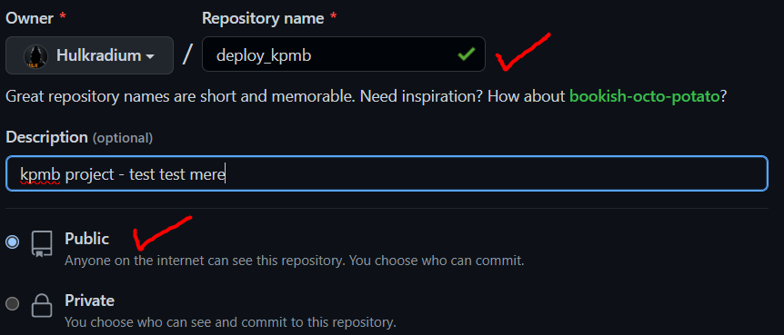
19. open folder project tadi
20. right click – click GitBash
21. 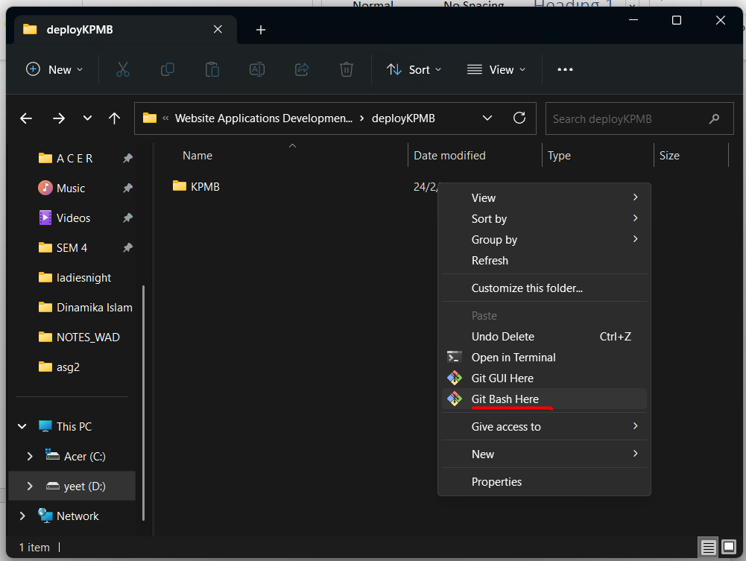
22. ^camni
23. dalam gitBash, type yang bawah
24. git init
25. git add .
26. git commit -m "first commit"
27. git remote add origin https://github.com/Hulkradium/deploy_kpmb.git
28. git push -u origin master
29. now sepatut ada dah file kita tadi tu dalam github
30. tutup gitBash, takmo guna dah
31. PythonAnywhere
32. bukak Bash
33. Graphical user interface, text, application, chat or text message

    Description automatically generated
34. amik code dari github then copy paste kat macam kat bawah
35. git clone <https://github.com/Hulkradium/deploy_kpmb.git>
36. mkvirtualenv --python=/usr/bin/python3.10 kpmbsite-virtualenv
37. pip install Django
38. ls
39. cd nama_file
40. ls
41. cd nama_file_besar
42. ls sampai jumpa requirements.txt
43. open new tab pythonanywhere
44. add a new web app
45. tekan je next next next
46. setup virtualenv
47. Graphical user interface, text, application

    Description automatically generated
48. kpmbsite-virtualenv
49. Graphical user interface, text, application, email

    Description automatically generated
50. copy paste bawah ni sejibik pastu nanti tukar skit skit – refer nom 66.

# +++++++++++ DJANGO +++++++++++

# To use your own Django app use code like this:

import os

import sys

# assuming your Django settings file is at '/home/myusername/mysite/mysite/settings.py'

path = '/home/myusername/mysite'

if path not in sys.path:

sys.path.insert(0, path)

os.environ['DJANGO_SETTINGS_MODULE'] = 'mysite.settings'

## Uncomment the lines below depending on your Django version

###### then, for Django >=1.5:

from django.core.wsgi import get_wsgi_application

application = get_wsgi_application()

###### or, for older Django <=1.4

#import django.core.handlers.wsgi

#application = django.core.handlers.wsgi.WSGIHandler()

1. Text

   Description automatically generated
2. edit ^ kat path dengan environ je
3. go to Bash balik
4. pip install -r requirements.txt
5. python manage.py createsuperuser
6. python manage.py migrate
7. Graphical user interface, text

   Description automatically generated
8. bukak web new tab
9. Graphical user interface, text, application

   Description automatically generated
10. bukak Files pastu gi directory kat bawah ni
11. 
12. Graphical user interface, text, application

    Description automatically generated
13. tukar allowed_hosts tu
14. bukak balik website tadi ha settle ah (kalau tak jadi, reload. tengok bawah)
15. 